ACM Chemical Biology 2019 14 12 2021 2022

1.Process and quality:
1.In NGC (Next generation curation) project performed as a QA lead & functional testing role Analysing and Understanding the Software Requirement Documents/ User Requirement Documents.
2.Collecting the requirements from BA and Incorporating the Validation points into the testcases.
3.Prepared the Test Scenarios & Test Cases based on the requirements.
4.Taking the required information and functional clarifications from the Functional team, Product owners, Project manager & SME's, BA.
5.Prepared & Executed the Entire application Testcases as per schedule. Maintained the Documents sheet as a summary.
6.Performed functional testing from end-to-end perspective of the tool.
7.Performed API Testing using Swagger Tool & Developer tools.
8.Peformed Non-functional testing (performance - load testing) on NGC tool.
9.Performed Regression testing of Entire application Testcases as per schedule.
10.Performed Ad hoc testing where appropriate testcases cannot be framed.
11.Reported the bugs using Azure Dev ops Tool as well as Excel sheets.
12.Weekly twice participating Defect triage meetings with Development team.
13.Participated in the meetings like Daily stand up & Communication calls, Sprint planning meetings, Requirement refinement calls, Sprint Retrospective meetings, Internal calls with the team.

1.All the Project goals and deliverables are delivered within the timelines with zero % Defects with quite accuracy. Whenever we received the build on each release tested and updating the results.
2.Performed Smoke & sanity testing at initial release if found any bugs reporting to the team.
3.Identifying the issues impacting on the stable application at early stages and informing to respective team members.
4.The Application is tested thoroughly on each release and sorted of all the bugs are raised and documented along with. The main aim is to cover all sort of bugs with various testing scenarios.
5.Capturing the Regression Test Cases results and finding the bugs in UAT environment after each release build / Version if found any.
6.Providing the required Doc's I.e UI Test cases of Complete application along with required Documentations.
7.Identifed bugs and raised in azure dev ops board regularly so the team will be aware on those bugs.

1.Gathering the requirements from the team and analysing the requirements for writing the testcases, executing the testcases and all the efforts to test the functionality from end-to-end perspective.
> For NGC project Initially tested both Scibase and Dcm Flow and it took around 4-5 months approximately.
> Later focused only on Scibase flow testing and it is still ongoing
> An estimated count of around 500+ bugs have been raised & reported to the team.

1.Practised the Automation Test scripts using selenium.
2.Developed the Automation Test scripts for NGC application for some stable modules
3.Due to un stability of the application automation implementation is difficult.
4.Tried Automating the application via temporary solution
5.R&D on automation and implemented multiple ways
6.Identified and resolved the issues in Automation Test scripts
7.Used Automation framework as TestNG and Data Driven for easy use and reusable.
8.Understanding and able to Modify/Change the Test scripts based on required scenarios.

1.Reporting the bugs using Excel sheets, Jira & Azure Dev ops Tools.
2.Maintaining and Documenting the testcases with respective of requirements.
3.Identifiying the bugs and reporting at early stages in Testing & UAT environment
4.Maintaining the Testcases in Excel sheet with required standards based on requirements
5.Daily updating the work status in W365 and Internally sharing the updates through mails and Calls.
6.Documenting everyday work and updating it accordingly.
7.Completed the certifications on Testing related courses in Percipio tool.
8.Learning the various resources like YouTube and enhancing the skills on the automation , Appium testing.

1.Completing the Tasks on time.
2.Acheived outstanding award in recent times
3.Handling multiple activity’s parallelly and monitoring the team
4.Performed functional testing from end-to-end perspective of the tool and Delivered the deliverables within the timelines with Zero % Defects.
5.Developing the Testcases and Executing the Testcases as per schedule.
6.Performed Regression testing of Entire application Testcases as per schedule.
7.Maintaining the All Testcases and Bugs sheet in common repository Like in Teams so everyone can access when they require.
8.Developed the Automation Test scripts for some stable modules.
9.Reporting the Bugs through Jira & Azure Dev ops Tool.
10.Participating all required meetings and calls.
11.Daily updating the work status in W365
12.Completed the certification on Testing related courses in Percipio tool.
13.Communicating openly with our team and gathering required information and functional clarifications from the Team.

Working in the NGC project was quite exciting where i implemented my skills and Knowledge for developing the product better.
As a QA Team lead participated in various activities daily and coordinating with the team members regularly in DSU’s and other meetings.
Analysing and understanding the end-to-end flow of the NGC application from all the validation documents. Also performed functional and non-functional (Performance) testing.
Based on the requirements prepared the Test cases & scenarios and tested as per schedule and updated the results accordingly.
Reporting the Bugs through Jira & Azure Dev ops Tool As well as Communicating openly with our team and gathering required information and functional clarifications from the Team.
Completing the tasks on time without delay on daily basis.

Hi Suresh & Sreekanth,

This mail is the formal QA Sign off to release in UAT, for NGC 1.1 (V2.5.0).

Following is the list of Screens/ Modules that has been tested and working fine:

1.Admin Screens (Role, User, Task Managements)
2.Master Entry Screens.
3.Mining, Curation, Review, QC form
i. Bibliography - Grid row Delete, Edit & Save
ii. Assay - Delete, Edit/Update & Save
iii. Activity Manual/Bulk and View entries - Delete, Cancel, Save & Update
iv. Structure - Delete, Edit, Merge and Save
v. Core group - Assigning ID and Update
4.Submit, zero record & Data Reject Function.
5.Automation - Task Loading, Task Mining (Automated)

Recent UAT Fixes:
1. Activity - Bulk update: Values are not saved if already existing compound/new compound is mapped to multiple assays, only one assay information is saved – To be fixed
2. Measured - Additional element: Remove validation between measured location: organ/tissue and measurement. - Remove Validation
3. Measured - Additional element: Remove validation between measured location: cells/fraction and measurement. - Remove Validation
4. Measured - Additional element: Remove validation between measured location: cell line and measurement - Remove Validation
5. Unable to save the Physiochemical data (clogp, clogd), Showing Error pop-up as 'Activity field is required' while saving. - Remove Validation
6. Activity: SAR value is blank is not saved; we have to enter the data without values also - Remove Validation

Please find the Below Known issues:
1.Bibliography - In Bibliography page data not extracting for automation task
2.Performance issues
3.Dropdown data for some fields - Pending with Scientific team.
4.While editing/deleting the data in curation/review/qc form in console sometimes getting error due to this not able to proceed further must reload the page (Occurring randomly).
5.Assay - While switching between the assay id's the previous assay data information was appearing in other assay ID's.
6.Sometimes while saving the structure throwing error at that time not able to carry forward must reload the page.(Occurring randomly)
7.Sometimes ME value does not populate immediately in the dropdown after raising the request.(Occurring randomly)
8.In Activity bulk Existing compounds mapping to multiple assays while saving with existing CEC in view entries CEC column data not getting correctly.

Thanks & Regards,
Wilson.G
NGC 2.0 QA Sign Off
Hi Sreekanth & Suresh,

This mail is the formal QA Sign off to release in UAT, for NGC 2.0 (V2.7.4).

Following is the list of Screens/ Modules that has been tested and working fine:

1.New and Revisit task curation flow
I. Bibliography - Auto save, Author company mapping, Grid row Delete, Edit , Save.
ii. Assay - Auto save, Delete, Edit/Update & Save
iii. Activity View entries – Manual Create and Save, Bulk Create and Save, View entries - Update, Delete, Filter and Replace
iv. Chemical space - Auto save, Save, duplicate structure Merge and Delete.
v. Submit, zero record and Reject.

Recent UAT Fixes:
1.Assay ECA and Additional compound fields performance Improvement
2.Structure saving performance Improvement
3. New excelra logo
Recent QA Fixes:
1. Chemical space - Unable to Submit QC task when unapproved value selected in salt field even after cleared the value and submit still showing validation msg.
2.Activity page - UAT - UOM dropdown is not working properly (all UOM's comes with contains not starts with)
Please find the list of Known issues count Below:
1.10 Non-Critical and Critical open bugs which Includes Technical feasibility, Nice to have issues.

Thanks & Regards,
Wilson.G
NGC 2.0 QA Sign Off
Hi Sreekanth,
This mail is the formal QA Sign off to release in UAT, for NGC 2.0 (V2.8.6).
Below bug has been tested and working fine:
Recent UAT/Prod Fixes:
1.Not able to convert exponential values 0.58e-8 into numerical values
Thanks & Regards,
Wilson.G
NGC 2.1 QA Sign Off
Hi Sreekanth,
This mail is the formal QA Sign off to release NGC 2.1 for UAT V3.0.14 (DCM).
Following is the list of Screens that has been tested and working fine:

1.Add reference
2.Bibliography
3.Assay
4.Activity
5.Chemical space

Please find the Below Known issues:
1.DCM - Curation form - Cancel function not working under all dcm pages
2.DCM> Add ref > old reference is not adding up in screen > patent, journal
3.DCM - Activity view entries - Able to filter and replace the data now but not working properly
4.DCM> Chemical space >Lag in typing and selecting data ; lag in switching to that tab
5.DCM> Add reference> Journal >Journal iso wrongly populated for old drug references
6.DCM>Add ref> Old reference of ref type 'O' not fetching as old data has no differentiation between book, url, report, conference.
7.DCM > Assay > Lag for typed values to appear in screen for range field > Kinetics value, Dose volume, dose strength
8.DCM - Assay - Once we get delete, delete confirmation msg pop up showing for other screens like Bibliography, Assay , Activity, Chemical space etc., when switching to other tab.

Thanks & Regards,
Wilson.G

NGC 3.0 QA Sign Off
Hi Sreekanth,
This mail is the formal QA Sign off to release in UAT, for NGC 3.0 (V2.2.8).
Below bug has been tested and working fine:
Recent UAT Fixes:
1.Not able to convert exponential values 0.58e-8 into numerical values

Please find the Below Known issues:
- QC Submit for in progress ME values no validation msg's
- Metabolism Tab not functional
- Zero record function (Not tested)
- Last significant update date & Last visit date will not populate (Pending with Vamsi)

Thanks & Regards,
Wilson.G

Hi Sreekanth,

This mail is the formal QA Sign off to release in UAT, for NGC 3.0 (V3.0.18).

Below bugs has been tested and working fine:

Hi Sreekanth,

This mail is the formal QA Sign off to release in UAT, for NGC 3.0 (V2.3.1).

Below bugs has been tested and working fine:
Recent UAT Fixes:

ID | Title
38695 | In mining curation task board, only records with overall status as 'mining curation progress' should be deletable
38696 | In mining task board, after clicking on delete button, record gets opened instead of deleted
38700 | In mining landing page and reviewer page, smiles is not getting validated properly
38701 | In mining landing page, after structure validation (based on smiles), in duplicate entry pop-up, record (s) from either NGC or GOSTAR is displayed instead of all records from both sources
38860 | In mining landing page, after searching with drug name/structure combination, validation is not happening for drug name.
38861 | For a GOSTAR record, post-validation, duplicate entry pop-up is displayed with no information on structure, phase-indication, and target-mechanism details
38862 | After searching with drug name or smiles, post-validation, 'new entry' pop-up in mining landing page and 'old drug entry' pop-up in mining reviewer page is displayed with broken image icon for 2D structure of the molecule
38863 | After creating a new record using 'smiles' (smiles to structure), structure window in mining curation page and mining reviewer page is displayed with broken image icon for 2D structure of the molecule
38594 | In mining landing page, validation is not happening for drug synonyms
38608 | Originator field missing in pop-up post drug name validation
38870 | Master entry request is raised without path (URL) and any file being uploaded in originator, indication, and protein fields in mining curation and reviewer pages
38871 | Unable to raise master entry request for target mechanism in mining curation and mining review pages
38877 | Structure retains in structure window even after deleting the SMILES, in mining landing, curation, and reviewer pages
38693 | 2D structure is not displayed after generating structure from smiles in mining landing page
38882 | Can create multiple GVK_IDs with same drug name and originator under CCD/DD. Validation to be implemented in mining curation and reviewer pages
38885 | Curation/review statuses, review allocation date, curation/review completion dates are not displayed properly
38900 | Field 'Link' for Others-URL is provided with text box to enter URL instead of upload file.
38963 | Synonym validation is not happening in chemical space
39011 | Can create duplicate patents by clicking multiple times on Action '+' button
39012 | Can add multiple references without using 'Add' button
39013 | Editing a reference is creating a new row with new Ref ID in Journal/Books/Conference/Reports/Product leaflet
39014 | Once a reference is added and saved, fields in journal, patent, and Others are editable without clicking on Edit button
39210 | 2D structure from structure window is not moving into biovia draw when trying to edit the structure
39656 | Unknown error message (object object) appearing while saving the data
39657 | Post-deletion, data retains in preview screens of Dev2:Dosage, CAEE, and CSD tabs; Once the data is deleted from grid table, data from preview screens should be deleted on-the-fly
39658 | Error message of compound name as mandatory is appearing without selection of 'is FDC' or 'Addl Compound' in Dev2:Dosage tab
39659 | Data in Age, Weight, and Size fields are not deleting; both using backspace/tab key and Clear button from pop-up
39660 | Study ID auto-generation is Indication dependent in CSD tab
39661 | Data saved successfully without Clinical Study Results or Conclusion
39662 | Data saved successfully without Study design
39637 | In mining curator page, post-validation, after clicking on 'Yes' button, 'Draw' button is disappearing
39668 | Adding and saving data for single component drug is not possible
39669 | Adding and saving data for single component drug in combination with additional compound is not possible
39674 | Data saved successfully without Indication or Population Condition
39678 | Data rows from child grids are not getting deleted completely when data row from parent grid is deleted
39769 | Structure is not getting deleted from Chemical structure window
39784 | When we select adverse event, value, grade all information and clicking on save getting unknown error msg "grade is applicable only when adverse event/efficacy endpoint value selected as adverse event row 1
39785 | If we select adverse event in dropdown and remove grade from grade column getting unknown error msg of [Object Object]
39792 | Drop-down field changed to free text in CAEE
39793 | After selecting 'Efficacyendpoint' from 'Adverse Event/Efficacy Endpoint' and adding data in the 'Value' field, the page is not saving. Instead, an unknown error message '[Object Object]' appears.
39804 | After filling in all the mandatory data, new records are getting saved successfully when clicking the Save button. However, earlier records are unable to be saved and are stuck with an 'Object-Object' error.
39811 | No master entry facility for Indication in Development 3: Phase
39817 | Data saved successfully with different phases being selected as highest phases
39823 | Master entry facility for 'Comp name' is not available (CAEE, CSD, Development 2: Dosage tabs)
39829 | No master entry facility for Salt form in Development 2: Dosage, CAEE, and CSD tabs
39735 | Data saved successfully pop-up coming without adverse event table and after again when we click on save then error msg of adverse event pop-up coming
39736 | Adverse event table dropdown not working; data is not appearing in Adverse event/Efficacy endpoint list
39737 | Raise request option is not present in Indication field
39818 | Endpoint accelerated data saved without check box selection in Accelerated field
39820 | No master entry facility for Name in Add Reference-Conference
39821 | No master entry facility for Indication (CAEE, CSD, Development 2: Dosage tabs)
39812 | No master entry facility for Compound Form Salt in Development 3: Phase
39814 | No master entry facility for Event Type in Development 3: Phase
39815 | Data saved successfully without sponsor information
39809 | Tab saved successfully when both 2D Structure and null check box selection are at one place in Chemical structure window
39787 | No master entry facility for company name in Others-Report
39679 | Data can be added in MBT database; CAEE is not applicable for MBT
39675 | Data saved successfully without 'comp name' when Addl comp check box is selected
39677 | Data saved successfully without any check box selected for 'Comp name'
39645 | In mining reviewer page, after deleting structure, data saved successfully with only source document and file
39667 | Inappropriate error message appearing while saving the data
39211 | Data remains after clicking on 'Clear All' button
39480 | Data saved successfully without drug agent
39481 | Data saved successfully without reference
39482 | Data saved successfully without reference
39483 | Can add contraindication and warning in a single datarow
38899 | Can access multiple records at one time
39209 | Closure button in structure window is functioning as open button for biovia draw
39611 | In mining curator/reviewer page, for originator, validation is not happening after deleting uploaded file; message to be appeared at the time of upload file submission
39632 | In mining curator/reviewer page, 2D structure is not generated from smiles
39634 | In mining curator/reviewer page, smiles to structure validation is not happening
39206 | In mining landing, post-validation, drug name/structure/smiles retain after closing new entry pop-up or duplicate entry pop-up
39207 | In mining landing, post-validation, drug name/structure/smiles retain after clicking on 'No' in new entry pop-up
39007 | Number-spinner (increase/decrease) button in PubMed ID field is not required
39010 | Day field is displayed with empty values
38694 | Notifications at bottom right should be persistent until user manually closes
38873 | Can create duplicate entries in list tables (where master entry request is applicable) with more than one space in between the words or with leading or trailing spaces/lines in entries being raised
38875 | Can create duplicate records from mining landing page/reviewer page with more than one space in between the words or with leading or trailing spaces/lines in drug name
38876 | Structure is generated with space in the SMILES; SMILES should be linear. Validation to be implemented for spaces/new lines.
38690 | Opening of Biovia draw from structure window using tab key is not possible
38869 | Once a record from GOSTAR is selected for updation, only GVK ID, Drug Name, and Database to be pulled into the curation/reviewer page
38691 | While opening biovia draw from structure window, inappropriate message is coming
38692 | Validation is happening without any data being entered in the smiles field
38689 | In mining landing structure window symbols are not defined
38886 | Mining curator or reviewer comments are retaining in the comments field after submission/rejection of the record
38878 | Change field name 'Source' to 'Originator' in upload file pop-up of originator field in mining curation and reviewer pages
38879 | Change field name 'Document path' to 'URL' in upload file pop-up of originator field in mining curation and reviewer pages
38880 | Change field name 'Source' to 'Synonym' in upload file pop-up of synonyms field in mining curation and reviewer pages
38881 | Change field name 'Document path' to 'URL' in upload file pop-up of synonyms field in mining curation and reviewer pages
39493 | Post-deletion, 2D structure of the molecule still retains in biovia draw
39673 | Efficacy ID auto-generation is 'Phase' dependent in CAEE tab
39724 | Complete deletion of a record from task board is not possible
39208 | Icon to open biovia draw in structure window is not visible

Please find the Below Critical Known issues:

ID | Title
35420 | DCM - MC - No Duplicate entry pop up showing when existing structure Drawn and validate (Biovia issue)
38269 | DCM> Add ref > old reference is not adding up in screen > patent, journal
38436 | DCM> Add reference> Journal >Journal iso wrongly populated for old drug references
38439 | DCM>Add ref> Old reference of ref type 'O' not fetching as old data has no differentiation between book, url, report, conference
38842 | DCM> Dev2 > Unable to select data in Compound name dropdown.(Where ever appliable Like CAEE, CSD)
39192 | DCM - Screen got stuck, when ME req raised (AZ copy complete not trigger)
39259 | DCM - Dev1 - When saving dev1 with filling drug description without modality & composition grids ref id is saving with null in db and Drug des, last significant date, last visit date not fetching
39455 | Scibase > Coregp > Substring search is throwing error
39646 | DCM - QC Submit for In progress ME values no validation msg's
39767 | Biovia draw is not opening when double clicked Chemical structure window
39726 | Auto-generation of Ref ID and Reference is not happening
39819 | No master entry facility for Organizer in Add Reference_Others_Conference
39835 | DCM > QC submit> Data was removed from the field yet throwing error

Please find the Below High Known issues:

ID | Title
39837 | Dev1> delivery technology is freetext now its dropdown
39840 | DCM> Chemical space > No molwt , mol formula displayed
39830 | Double click is required for opening dropdown in reference field
39853 | DCM - Formulation details - Fill ROA & ROE and save throwing validation msg after i cleared that fields even though getting the validations.
39816 | Double click is required for opening dropdown in reference field (Phase and Milestones tables)
39855 | DCM - DEV3 - Cleared data again fetching back while updating
39822 | Double click is required for opening dropdown in reference field (CAEE, CSD, and Development 2: Dosage tabs)
39824 | Double click is required for opening dropdown in 'Value' field when adverse event is selected from 'Adverse Event/Efficacy Endpoint'
39825 | Master entry facility for list table in 'Value' field is not available
39826 | Master entry request is implemented for Radio/Chemo in CAEE, CSD, Development 2: Dosage tabs; not needed
39719 | DCM - Contraindication - Disable the Contraindication , Dev3 tab for MBT task not save disabling
39810 | Double click is required for opening dropdown in reference field
39666 | Lag in opening 'Comp Name' list table and entry selection in tabs CSD, CAEE, and Dev2:Dosage tabs
39801 | Unable to view uploaded files in Journal/Patent/Others (URL, Books, Conference, Reports, and Product Leaflet)
39802 | While opening an uploaded file, tool gets stuck if the file name contains symbols like '+', '%', etc.
39803 | Option to delete a file is not present when multiple files are uploaded
39805 | DCM - Assay - Filled Additional compound role and same value entered in ECA field even thought getting validation msg.
39752 | In mining curation and review page, unknown error message is appearing while opening the uploaded document
39762 | DCM > Row retain > Remove orange colour when the user edits dose or any other fields, because dose is mandatory and will have diff values
39763 | In mining landing structure search/validation is not happening
39630 | In mining curator/reviewer page, validation is happening for blank structure
39478 | Can create duplicate rows; need a validation
34268 | Assay - UAT - To add Navigation keys for assay page and select all check box option for activity values
34645 | Activity/Assay/Bibliography - UAT - Cursor placing and clearing the values is difficult using mouse for all range and freetext fields
35501 | DCM - TM -TA - Unable to view Mining curator name under Mining curated task list grid (Mining review) & Rejected column missing under mining reviewer user's list

Thanks & Regards,
Wilson.G

NGC 3.0 QA Sign Off

Hi Sreekanth,

This mail is the formal QA Sign off to release in UAT, for NGC 3.0 (V2.3.4).

Following is the list of Screens/ Modules that has been tested and working fine:

1.New task curation flow
I. Bibliography, Assay, Activity Manul, Bulk update & Activity view entries, Chemical space, Core group, Dev1,2,3, Contraindication, Drug Interaction, Metabolism, Clinical adverse event, Clinical study details tabs
ii. Submitted Curation, Review and QC
iii. Rejection flow
Please find the Bug fixes after UAT release (From Feb 11th):

Please find the list of CR’s implemented after UAT release (From Feb 11th) :

Known items:

Hi
Please find the below plan for Testing.
Scope of Testing:
In Scope:
1.Testing recent Bug fixes and CR's.
2.Relavent Test cases along with critical path application flow.
3.Dev & UAT Team support.

Out of Scope:
1.Nonfunctional testing.

Test Objectives:

- Verify all new features meet acceptance criteria
- Ensure all bugs marked for the sprint are fixed and closed
- Regression test existing profile features

Testing Types performed:
- Sanity Testing
- Functional Testing
- Regression Testing

Pending Test activities and deliverables:
Timelines - 8 days
1)Bug Fix’s list
i)42299 - Resolved
ii)42305 - Resolved
iii)42352 - Resolved
iv)42353 - Resolved
v)41440 - Reopen
vi)41482
vii)42193
viii)42317
ix)42318
x)42320
xi)42323
xii)42298 - Resolved

2)CR’s list
i)41185 - Resolved
ii)41924
iii)42047
iv)42286

3)Test Cases list

i)42497
ii)42498
iii)42499
iv)42500
v)42501
vi)42502
vii)42503
viii)42504
ix)42505 – Covered bug raised
x)42506 – Covered bug raised
xi)42507
xii)42496

Tools Used:
- Bug Tracking – Azure devops

Note:
Timelines may vary depending on the number and severity of defects and CR’s and Test cases during testing.
Thanks & Regards,
Wilson.G

Timelines may vary depending on the number and severity of defects and CR’s and Test cases

Hi Sreekanth,

Please find the below plan for Drug ID Testing.

Scope of Testing:

In Scope:
1.Creating Testcases for Drug ID User story’s
2.Testing User story’s and Executing Relevant Test cases of Drug ID along with critical path application flow.

Out of Scope:
1.Nonfunctional testing.

Test Objectives:

- Verify all new features meet acceptance criteria
- Regression test existing profile features

Testing Types performed:

- Functional Testing
- Regression Testing

Test activities and deliverables Timelines – 10 Days:

ID | Title
42900 | Drug ID - DB changes.
42899 | Drug ID - UI implementation
43422 | Mapping Drug ID-GVK ID - API development
42902 | Mining - Drug ID - API development
43423 | Drug ID > Fetch gvk id based on ref Id for Add ref Tab - API
43424 | Drug ID - Fetch gvk id based on ref Id for Add ref Tab - UI
42904 | Drug ID > GVKID generation and CEC entries- API development
43428 | Drug ID-GVKID changes in Task management screens > API
43427 | DCM > Curation form SAVE based on DrugId - API
42903 | Drug ID > Permissions and restrictions for discovery refIds and vice versa- API development
43425 | DCM > Curation form fetch based on DrugId - API
43429 | DrugID> ME dropdown validation changes at QC submission > API

Tools Used:
- Bug Tracking – Azure devops

Note:
Timelines may vary depending on the number and severity of User story’s and Test cases during testing.
Thanks & Regards,
Wilson.G

Timelines
Hi Sreekanth,

This mail is the formal QA Sign off to release in UAT, for NGC 3.0 (V2.4.0).

Following is the list of Screens/ Modules that has been tested and working fine:

1.New task curation flow
i. Mining Curator & Mining Reviewer, Bibliography, Assay , Activity Manual, Bulk update & Activity view entries, Chemical space, Core group, Dev1,2,3, Contraindication, Drug Interaction, Metabolism, Clinical adverse event, Clinical study details, Add reference tabs
ii. Submitted Curation, Review and QC
iii. Rejection flow

Please find the Bug fixes after UAT release (From April 2nd):

Count : 142

Please find the list of CR’s implemented after UAT release (From Apr 2nd) :

Count : 55

Please find the list of TestCases link which was tested in recent exe:
https://excelra.visualstudio.com/Next%20Gen%20Curation%202.0/_testPlans/define?planId=43566&suiteId=43567

Combined Testing Recordings:
- Recap: Discovery Combined Testing 13 May
- Recap: DCM - Combined Testing 28 May
- Recap: DCM- Combined testing 15 May
- Recap: DCM- Combined testing 16 May
- Recap: DCM- Combined testing 19 May
- Recap: DCM- Combined testing 20 May
- Recap: DCM- Combined testing 21 May
- Recap: DCM- Combined testing 22 May
- Recap: DCM- Combined testing 23 May
- Recap: Combined Testing 03 June
- Recap: Combined Testing 04 June
- Recap: Combined Testing 06 June

Known Items:

Hi Sreekanth,

This mail is the formal QA Sign off to release in UAT, for NGC 3.0 (V2.4.0).

Below bug has been tested and working fine:

Recent UAT Fixes:
- Bug 44032: For a record that is in 'QC In Progress' status and is reassigned to another user (User 2), the original QC's (User 1's) skip review status incorrectly updates to 'Reassigned', and the QC allocation date for User 1 is missing. - Resolved
- Bug 42780: The reassigned mining task, previously rejected, is displaying as "Rejected" to the new user. It should be shown as "New Task." - Resolved

Thanks & Regards,
Wilson.G

Hi,

Please find the below plan for Drug ID Testing.

Scope of Testing:

In Scope:
1.Creating Testcases for Drug ID User story’s
2.Testing User story’s and Executing Relevant Test cases of Drug ID along with critical path application flow.

Out of Scope:
1.Nonfunctional testing.

Test Objectives:

- Verify all new features meet acceptance criteria
- Regression tests existing profile features

Testing Types performed:

- Functional Testing
- Regression Testing

Test activities and deliverables Timelines – 10 Days:

ID | Title
42900 | Drug ID - DB changes.
42899 | Drug ID - UI implementation
43422 | Mapping Drug ID-GVK ID - API development
42902 | Mining - Drug ID - API development
43423 | Drug ID > Fetch gvk id based on ref Id for Add ref Tab - API
43424 | Drug ID - Fetch gvk id based on ref Id for Add ref Tab - UI
42904 | Drug ID > GVKID generation and CEC entries- API development
43428 | Drug ID-GVKID changes in Task management screens > API
43427 | DCM > Curation form SAVE based on DrugId - API
42903 | Drug ID > Permissions and restrictions for discovery refIds and vice versa- API development
43425 | DCM > Curation form fetch based on DrugId - API
43429 | DrugID> ME dropdown validation changes at QC submission > API

Tools Used:
- Bug Tracking – Azure devops

Note:
Timelines may vary depending on the number and severity of User story’s and Test cases during testing.
Thanks & Regards,
Wilson.G

J. Nat. Prod., 2025, 66 (764), 200-275 , 9001785 (Discovery to Dev)

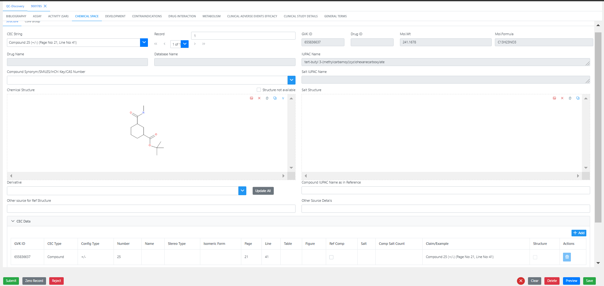
+

J. Nat. Prod., 2025, 23 (14), 126-240 , 9001236 (Discovery to Dev)
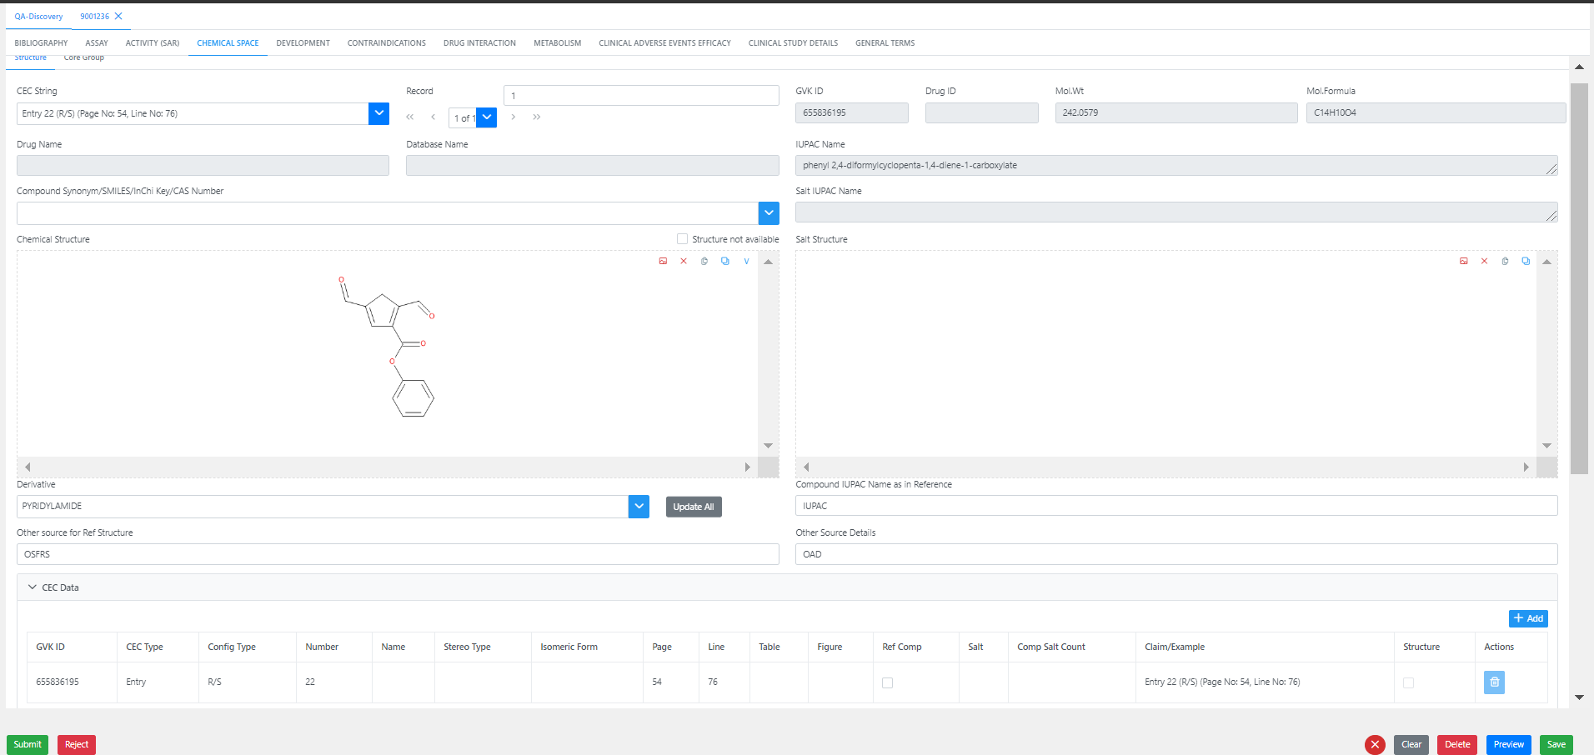
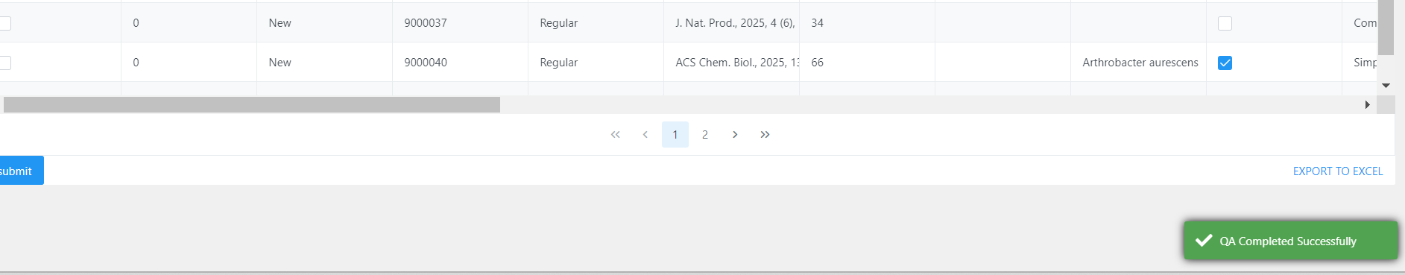
Loaded in DEV flow

ACS Chem. Biol., 2025, 33 (66), 62-68 , 9001788

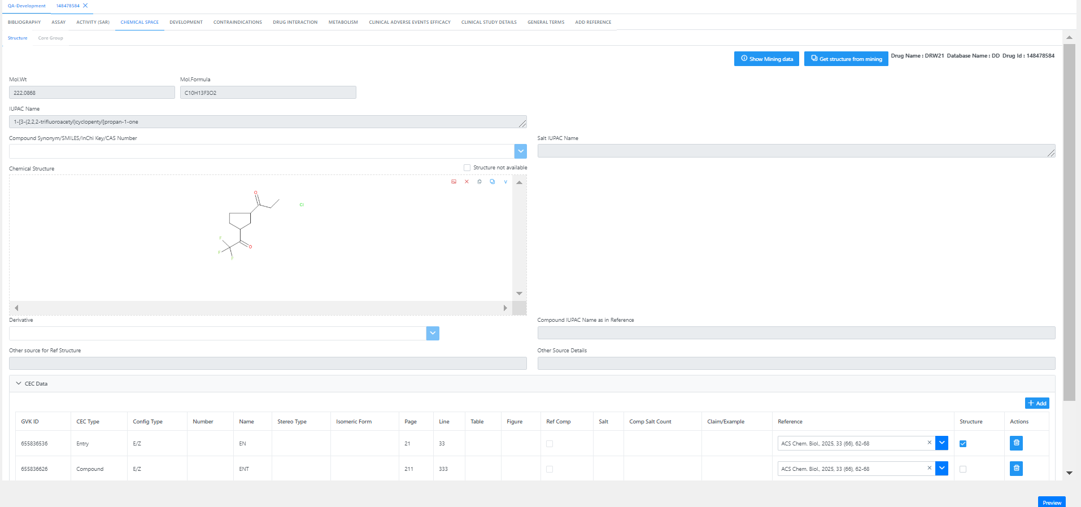
Loaded in Discovery flow

NGC QA Sign Off v3.1.1 Release
Hi Vamsi & Sreekanth,

This mail is the formal QA Sign off to release in UAT for NGC 3.0 (V3.1.1).

Please find the Recent UAT/Prod Bug fix:
Count :

Please find the Recent User story’s Implemented:

Count :

Note: In Combined testing Tested most of the bug fixes and story’s and confirmed it’s working in DEV V3.1.1.

Please find the Yet to be done in QA Bugs & Stories:

Count :

Please find the list of TestCases link which was tested in recent exe:

https://excelra.visualstudio.com/Next%20Gen%20Curation/_testPlans/define?planId=49561&suiteId=49562
Known Items:

Test Plan for Q4.2 & Q4.3
Hi,

Please find the below plan for In QA Items Testing.

Scope of Testing:

In Scope:
1.Creating Testcases for New User story’s
2.Testing Bugs & User story’s and Executing Relevant Test cases.

Out of Scope:
1.Nonfunctional testing.

Test Objectives:

- Verify all new features meet acceptance criteria
- Regression tests existing profile features

Testing Types performed:

- Functional Testing
- Regression Testing

Test activities and deliverables Timelines – 10 Days:

ID | Title
42900 | Drug ID - DB changes.
42899 | Drug ID - UI implementation
43422 | Mapping Drug ID-GVK ID - API development
42902 | Mining - Drug ID - API development
43423 | Drug ID > Fetch gvk id based on ref Id for Add ref Tab - API
43424 | Drug ID - Fetch gvk id based on ref Id for Add ref Tab - UI
42904 | Drug ID > GVKID generation and CEC entries- API development
43428 | Drug ID-GVKID changes in Task management screens > API
43427 | DCM > Curation form SAVE based on DrugId - API
42903 | Drug ID > Permissions and restrictions for discovery refIds and vice versa- API development
43425 | DCM > Curation form fetch based on DrugId - API
43429 | DrugID> ME dropdown validation changes at QC submission > API

Tools Used:
- Bug Tracking – Azure devops

Note:
Timelines may vary depending on the number and severity of Bugs, User stories and Test cases during testing, few user stories can be moved to UAT once relevant bugs are closed.
Thanks & Regards,
Wilson.G

Open tool
Go to project manager discovery
Task loading
Load Existing ref id along with other valid data and upload

Unable to revalidate the task which we edited in Validation error tab
Cleared all data except existing Ref id and revalidated
Screen getting empty

